DEPARTMENT OF CSE, CS&IT, AI&DS
COURSE CODE: 24SDCS02 / 24SDCS02E / 24SDCS02P / 24SDCS02L
FULL STACK APPLICATION DEVELOPMENT

Date of the Session: / / Time of The Session: to

#SKILL - 1 Git Version Control
Prerequisites:
- Basic knowledge of Git commands
- Ability to create and edit project files
- Understanding of version control basics

The development team wants to manage their project using Git to maintain a structured and collaborative workflow. In this lab, you will simulate a real-world version control process: creating project files, tracking and committing changes, using GitHub as remote storage, working with multiple branches, and handling merge conflicts. This helps you understand how developers work together efficiently in software projects.
Tasks:
- Create a new project folder, initialize Git using git init, and configure Git with your username and email.
- Create two files (example: main.java, notes.txt) with sample content, check the repository status, and add them to staging.
- Commit the staged files with a meaningful commit message.
- Create a new repository on GitHub, connect your local repo using the remote URL and push the committed changes.
- Create the first branch (example: feature-update), make modifications, and add + commit the changes.
- Create a second branch (example: bug-fix), apply changes, and add + commit them.
- Switch back to the main branch and merge both branches one after the other.
- If any merge conflict occurs, resolve it manually, commit the fix, and complete the merge.

Git commands:
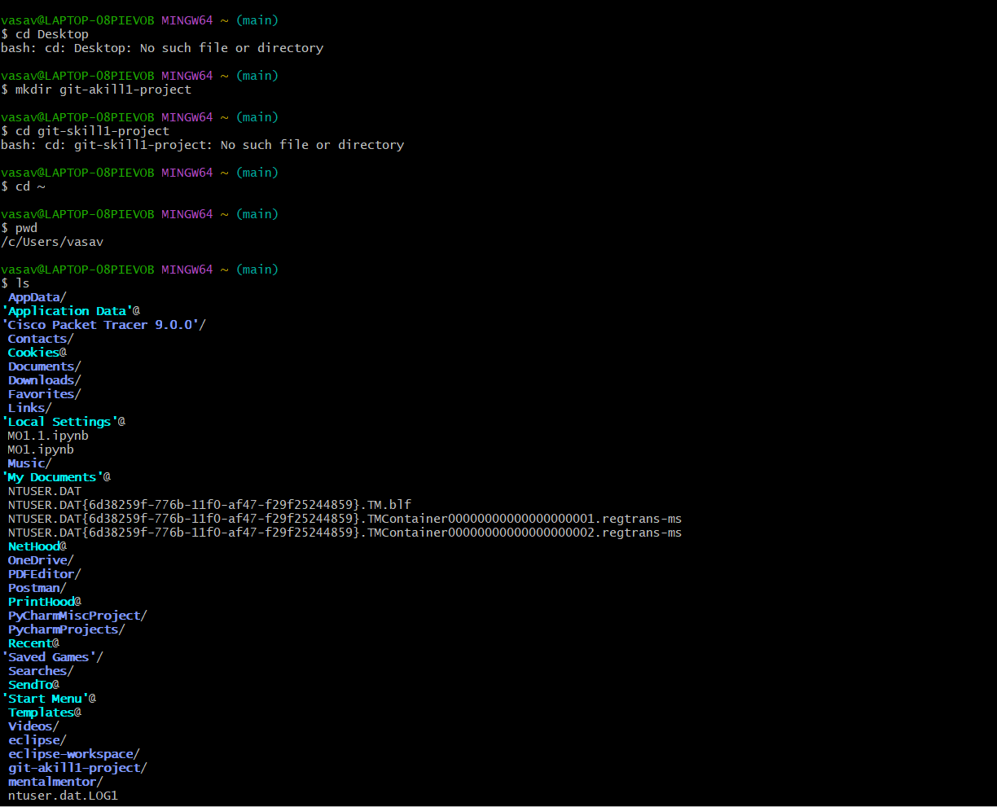

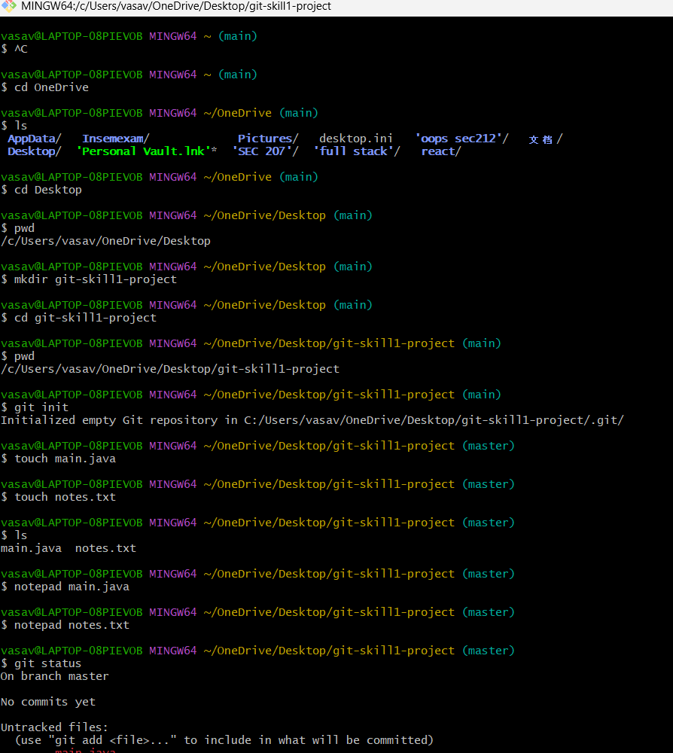

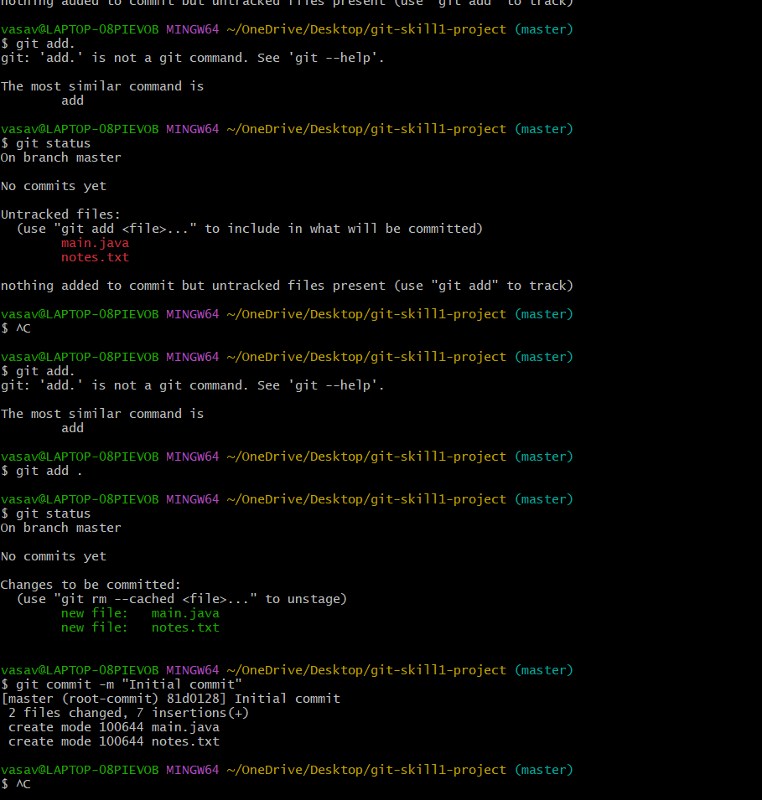
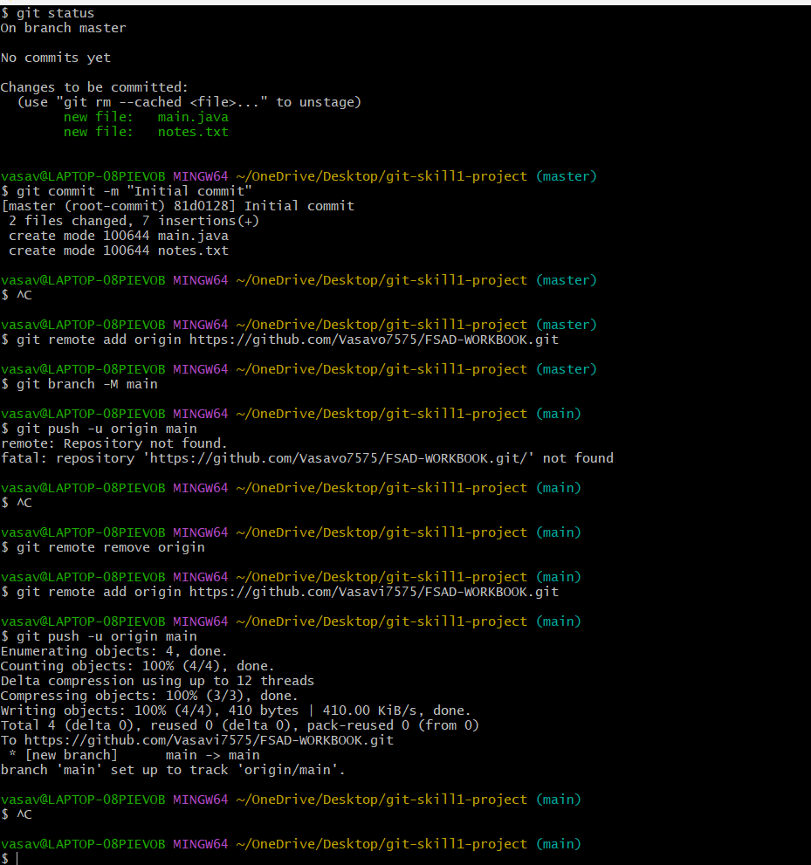

Main.java
public class Main {
public static void main(String[] args) {
System.out.println("Hello Git");
}
}

Notes.txt
Git Skill 1 Lab
Basic version control practice

VIVA QUESTIONS:

  - Why is Git used in development?
  - What information is stored in Git configuration?
  - What is Maven and why is it used?
  - What is the role of the POM.xml file?
  - Explain Maven Build Life Cycle.

1Ans: Git is a version control system that helps developers manage changes to their code.
Reasons for using Git:
- Tracks the history of code changes.
- Allows multiple developers to collaborate on the same project.

2Ans:Git configuration stores settings that control Git behavior. There are three levels: system, global, and local.
Information stored includes:
- User identity: user.name and user.email
- Default text editor for commits
You can view it with:
Command: git config –list

3Ans: Maven is a build automation and dependency management tool for Java projects.
Why it’s used:
- Manages project build process (compilation, packaging, testing, deployment).
- Handles dependencies automatically (libraries required by the project).
- Supports plugins to extend functionality (e.g., generating reports, running tests).

4Ans: The POM (Project Object Model) file is the core configuration file of a Maven project.
It defines:
- Project information: name, version, description
- Dependencies needed by the project
- Source directories and packaging type (jar, war, etc.)

5Ans: Maven has three built-in build life cycles: default, clean, and site. The most important is default, which handles project build.
Phases of Default Build Life Cycle:
- validate – Check if project is correct and necessary info is available.
- compile – Compile the source code.
- test – Run tests using a testing framework (e.g., JUnit).
- package – Package compiled code into a JAR/WAR.
- verify – Run checks to ensure the package is valid.
- install – Install the package into the local Maven repository.
- deploy – Deploy the package to a remote repository for sharing.

